**Board member list:**

**INEDs**

Carlson TONG * GBS, JP (Chairman)

Nicholas Charles ALLEN

Apurv BAGRI BBS (resigned since 2025 AGM)

CHAN Kin Por * GBS, JP

CHEAH Cheng Hye

CHEUNG Ming Ming, Anna

CHIA Pun Kok, Herbert * JP

CHOW WOO Mo Fong, Susan *

LEUNG Nisa Bernice Wing-Yu * MH, JP (resigned since 2025 AGM)

LEUNG Pak Hon, Hugo

YAM Chi Kwong, Joseph * GBM, GBS, JP

ZHANG Yichen

Peter Wilhelm Hubert BRIEN (appoint since 30 April 2025)

DING Chen (appoint since 30 April 2025)

**Executive Director**

CHAN Yiting, Bonnie (Chief Executive Officer)

**Group Company Secretary**

Timothy TSANG

**CEO: Bonnie Y CHAN (Director and Chief Executive Officer) *(Newly appointed)***

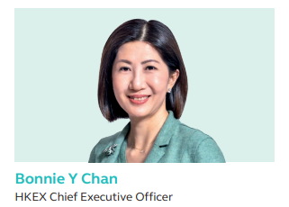

**Education Background**

* **Bachelor of Laws**: University of Hong Kong
* **Master of Laws**: Harvard Law School
* **Professional Qualifications**:
  + Admitted as a solicitor in Hong Kong
  + Admitted as an attorney at law in New York State

**Previous and Current Positions**

* **Current Position**:
  + **Title**: Chief Executive Officer
  + **Organization**: Hong Kong Exchanges and Clearing Limited (HKEX)
  + **Term**: 1 March 2024 to 28 February 2027
  + **Ex-officio Member**: Board of Directors
* **Previous Positions**:
  + **Co-Chief Operating Officer**: HKEX (February 2023 – February 2024)
  + **Head of Listing**: HKEX (January 2020 - January 2023)
  + **Head of IPO Transactions**: HKEX (2007-2010)
  + **Partner**: Davis Polk & Wardwell LLP (2010-2019)
  + **Executive Director**: Morgan Stanley, Legal and Compliance Department (2003-2007)
* **Other Roles**:
  + Member of various HKEX committees and advisory councils
  + Member of the Financial Services Development Council (2015-2020)
  + Member of public service panels including HKUST Business School Advisory Council (2025~) and Listing Policy Panel (2024~)

**LinkedIn profile:** N/A

**CFO: Lau Bik Yun, Vanessa**

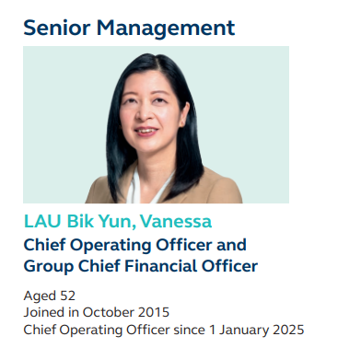

**Education Background**

* **Bachelor of Arts**: Mathematics and Computation, University of Oxford, UK
* **Master of Arts**: Mathematics and Computation, University of Oxford, UK
* **Professional Qualification**: Associate, The Institute of Chartered Accountants in England and Wales

**Previous and Current Positions**

* **Current Position**:
  + **Title**: Chief Operating Officer and Group Chief Financial Officer
  + **Joined**: October 2015
  + **COO Since**: 1 January 2025
* **Other Positions Held with the Group**:
  + **Chief Executive**: HKFE (Hong Kong Futures Exchange)
  + **Chief Executive**: HKSCC (Hong Kong Securities Clearing Company)
  + **Chief Executive and Chairman**: SEHK (Stock Exchange of Hong Kong), Compensation Committee
* **Other Major Offices**:
  + **Independent Non-Executive Director**: Swiss Re Ltd (listed on SIX Swiss Exchange) (2023~)
* **Past Offices**:
  + **Co-Chief Operating Officer**: HKEX (2024)
  + **Chief Financial Officer**: HKEX, Hong Kong (2017-2020)
  + **Deputy Chief Financial Officer**: HKEX (2015-2017)
  + **Vice President and Senior Research Analyst**: Sanford C Bernstein (Hong Kong) Limited (2011-2015)
  + **Group Chief Financial Officer**: Alcoa Inc, Global Rolled Products Group (2007-2011)
  + **Various Positions**: McKinsey & Company Inc (2001-2007), including Associate Principal (Hong Kong, 2005-2007)
  + **Various Positions**: PricewaterhouseCoopers (UK) (1994-2000), including Senior Tax Manager in Mergers and Acquisitions Tax Group (1999-2000)

**LinkedIn profile:** N/A

**Mr Carlson Tong, Chairman, INED, appointed effective as at 3 May 2024**

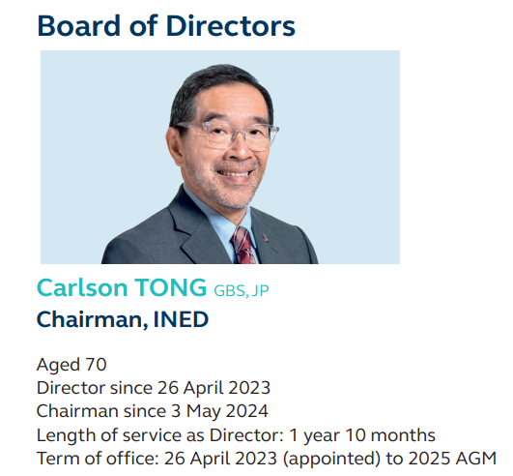

**Education Background**

* **Fellow**:
  + Institute of Chartered Accountants in England and Wales (ICAEW)
  + Hong Kong Institute of Certified Public Accountants
* **Honorary Doctorates**:
  + Doctor of Business Administration, Hong Kong University of Science and Technology
  + Doctor of Social Science, Chinese University of Hong Kong
  + Doctor of Social Sciences, Education University of Hong Kong
* **Honorary Fellow**:
  + Lingnan University
  + Hong Kong Academy of Finance

**Previous and Current Positions**

* **Current Position**:
  + **Title**: Chairman
  + **Organization**: Hong Kong Exchanges and Clearing Limited (HKEX)
  + **Independent Non-Executive Director**: Since 26 April 2023
  + **Chairman Since**: 3 May 2024
  + **Term of Office**: 30 April 2025 to 2027 AGM
* **Other Positions Held with the Group**:
  + Chairman of various committees at HKEX (Executive, Corporate Responsibility, Nomination and Governance, Remuneration, Risk Management)
  + Member of Listing Nominating Committee, The Stock Exchange of Hong Kong Limited
  + Chairman and Director of HKEX Foundation Limited
  + Director of HKEX Global Commodities Limited
* **Other Major Offices**:
  + Independent Non-Executive Director, Standard Chartered Bank (Hong Kong) Limited (2024~)
  + Director, World Federation of Exchanges (2024~)
  + Non-Official Member, Hong Kong Investment Corporation Limited (2023~)
  + Independent Non-Executive Director, MTR Corporation Limited (2022~)
* **Past Offices**:
  + Observer, Cathay Pacific Airways Limited (2020-2024)
  + Independent Non-Executive Director, Standard Chartered PLC (2019-2024)
  + Chairman, Hong Kong University Grants Committee (2016-2022) and Member (2011-2013)
  + Non-Executive Director, Hong Kong International Airport Authority (2017-2020)
  + Chairman, Securities and Futures Commission (2012-2018) and Non-Executive Director (2011-2018)
  + Various positions at KPMG (1979-2011) including Asia Pacific Chairman, Global Board Member
* **Public Service**:
  + Member, International Advisory Council of National Financial Regulatory Administration (2024~)
  + Member, Listing Policy Panel (2024~)
  + Chairman, Task Force on Enhancing Stock Market Liquidity (2023~)
  + Member, Judicial Officers Recommendation Commission (2023~)
  + Chairman, Independent Commission on Remuneration for Members of the Executive Council and the Legislature (2017~)

**LinkedIn profile:** <https://hk.linkedin.com/in/carlson-tong-41b02a186>

**Nicholas Charles ALLEN**

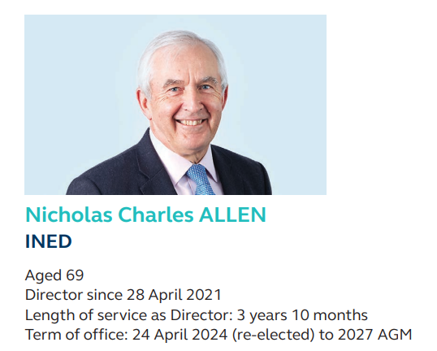

**Education Background**

* **Bachelor of Arts**: Economics/Social Studies, The University of Manchester, UK
* **Professional Qualifications**:
  + Associate, Hong Kong Institute of Certified Public Accountants
  + Fellow, The Institute of Chartered Accountants in England and Wales

**Previous and Current Positions**

* **Current Position**:
  + **Title**: Independent Non-Executive Director
  + **Joined**: 28 April 2021
  + **Term of Office**: 24 April 2024 to 2027 AGM
* **Other Positions Held with the HKEX Group**:
  + Chairman of Audit Committee
  + Member of Nomination and Governance Committee, Remuneration Committee, and Risk Committee
* **Other Major Offices**:
  + **Non-Executive Director**: The London Metal Exchange, Chairman of Audit Committee, Member of Remuneration Committee
  + **Non-Executive Director**: LME Clear Limited, Chairman of Audit Committee, Member of Nomination Committee and Remuneration Committee
  + **Independent Non-Executive Director**: Mordril Properties Limited (2019~)
  + **Independent Non-Executive Director**: CLP Holdings Limited (2009~)
* **Past Offices**:
  + **Chairman and Independent Non-Executive Director**: Link Asset Management Limited (2016-2024)
  + **Independent Non-Executive Director**: Lenovo Group Limited (2009-2021)
  + **Independent Non-Executive Director**: RAK Rock LLC (2018-2021)
  + **Independent Non-Executive Director**: Stevin Rock LLC (2018-2021)
  + **Independent Non-Executive Director**: VinaLand Limited (2010-2016)
  + **Independent Non-Executive Director**: Hysan Development Company Limited (2009-2016)
  + **Partner**: PricewaterhouseCoopers (1998-2007)
  + **Partner**: Coopers & Lybrand (1977-1998)

**LinkedIn profile:** <https://hk.linkedin.com/in/nicholas-allen-78b1a9a9>

**CHAN Kin Por**

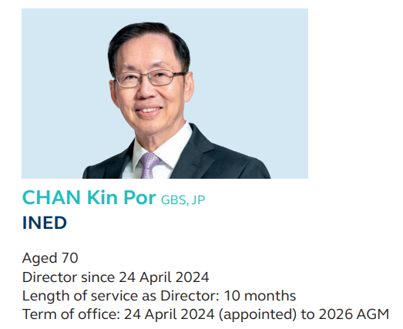

**Education Background**

* **Qualifications**:
  + Chartered Insurance Practitioner
  + Associate, The Chartered Insurance Institute, UK

**Previous and Current Positions**

* **Current Position**:
  + **Title**: Independent Non-Executive Director
  + **Joined**: 24 April 2024
  + **Term of Office**: 24 April 2024 to 2026 AGM
* **Other Positions Held with the HKEX Group**:
  + Member of Corporate Responsibility Committee and Investment Committee
  + Director, HKEX Foundation Limited
* **Other Major Offices**:
  + **Director**: The Chinese University of Hong Kong Medical Centre (2025~)
* **Past Offices**:
  + **Chief Executive Officer and Executive Director**: Well Link Insurance Group Holdings Ltd (2019-2022), Senior Advisor (February-May 2019)
  + **Independent Non-Executive Director**: Bank of East Asia, Limited (2017-2019)
  + **Member**: Munich Re China Advisory Board (2009-2016), Chief Executive Officer (Hong Kong branch) (2005-2009)
  + **Director and General Manager**: Hang Seng Insurance Company Limited (1999-2005)
  + **Director**: Hang Seng Life Limited (1995-2005)
  + **Various Positions**: Hang Seng Bank Limited (1974-2005), including Assistant General Manager and Head of Insurance Group (1999-2005)
* **Public Service**:
  + **Chairman**: Independent Commission Against Corruption (ICAC) Advisory Committee on Corruption (2025~)
  + **Non-Official Non-Executive Director**: Urban Renewal Authority (2025~)
  + **Deputy Chairman**: Legislative Council of the Hong Kong Special Administrative Region, House Committee (2024~)
  + **Member**: Legislative Council (Insurance Functional Constituency) (2008~)
  + **Member**: Honours and Non-official Justices of Peace Selection Committee (2023~)
  + **Non-Official Member**: Executive Council of the Hong Kong Special Administrative Region (2022~)
  + **Member**: Committee of the Presidium of the HKSAR of the 14th National People’s Congress (2022~)

**LinkedIn profile:** N/A

**CHEAH Cheng Hye**

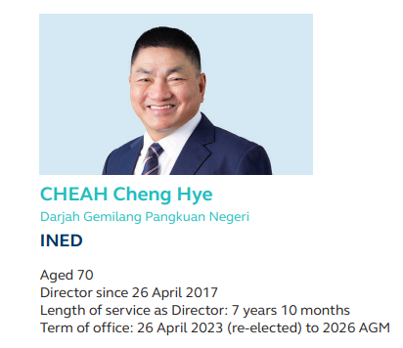

**Education Background**

* **Qualifications**:
  + Honorary Fellow, The Hong Kong University of Science and Technology

**Previous and Current Positions**

* **Current Position**:
  + **Title**: Independent Non-Executive Director
  + **Joined**: 26 April 2017
  + **Term of Office**: 26 April 2023 to 2026 AGM
* **Other Positions Held with the HKEX Group**:
  + Chairman of Investment Committee
  + Member of Board Executive Committee, Listing Operation Governance Committee, and Nomination and Governance Committee
  + Member of Listing Nominating Committee, The Stock Exchange of Hong Kong Limited
* **Other Major Offices**:
  + **Honorary Chairman and Non-Executive Director**: Value Partners Group (2025~)
* **Past Offices**:
  + **Co-Chairman and Co-Chief Investment Officer**: Value Partners Group (2019-2025)
  + **Executive Director**: Value Partners Group (1993-2025)
  + **Co-Chief Investment Officer**: Value Partners Group (2010-2019)
  + **Chairman**: Value Partners Group (2000-2019)
  + **Chief Investment Officer**: Value Partners Group (1993-2010)
  + **Executive Director, Head of Research and Proprietary Trader**: Morgan Grenfell Group, Hong Kong (1989-1993)
  + **Editor and Financial Journalist**: Various publications including The Asian Wall Street Journal and Hong Kong Standard (1971-1989)
* **Public Service**:
  + **Member**: HKTDC Mainland Business Advisory Committee (2023~)
  + **Member**: HKTDC Belt and Road & Greater Bay Area Committee (2019~)
  + **Member**: Listing Policy Panel (2018~)

**LinkedIn profile:** N/A

**CHEUNG Ming Ming, Anna**

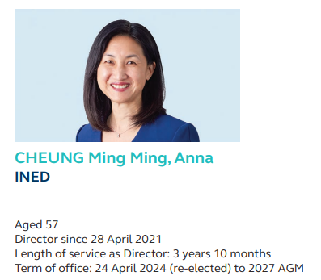

**Education Background**

* **Bachelor of Arts**: Computer Science, University of California, Berkeley, US
* **Master of Business Administration**: Finance, The Wharton School, University of Pennsylvania, US

**Previous and Current Positions**

* **Current Position**:
  + **Title**: Independent Non-Executive Director
  + **Joined**: 28 April 2021
  + **Term of Office**: 24 April 2024 to 2027 AGM
* **Other Positions Held with the HKEX Group**:
  + Member of Audit Committee, Board Executive Committee, Corporate Responsibility Committee, Nomination and Governance Committee, and Remuneration Committee
  + Director, HKEX Foundation Limited
* **Other Major Offices**:
  + **Independent Non-Executive Director**: HKBN Ltd (2023~)
  + **Director**: LGT Capital Partners Group Holding Ltd (2021~)
* **Past Offices**:
  + **Chief Executive**: Jardine Pacific Limited (2015-2020)
  + **Senior Advisor**: FountainVest Partners (2013-2015)
  + **Senior Advisor**: LionRock Capital (2012-2013)
  + **Partner**: 3i Group Plc (2001-2012), including roles from 2008-2012

**LinkedIn profile:** <https://hk.linkedin.com/in/anna-cheung-51bb75b8>

**CHIA Pun Kok, Herbert**

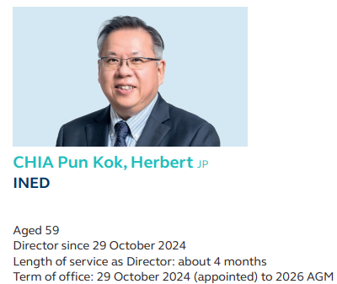

**Education Background**

* **Executive Master of Business Administration**:
  + Tsinghua University, PRC
  + Institut Européen d'Administration des Affaires (INSEAD)

**Previous and Current Positions**

* **Current Position**:
  + **Title**: Independent Non-Executive Director
  + **Joined**: 29 October 2024
  + **Term of Office**: 29 October 2024 to 2026 AGM
* **Other Positions Held with the HKEX Group**:
  + Member of Audit Committee, Investment Committee, and Risk Committee
* **Other Major Offices**:
  + **Senior Advisor**: Alibaba Cloud Intelligence (North APAC Region) (2024~)
  + **Professor of Practice**: Hong Kong Management Association (2023~)
  + **Adjunct Associate Professor**: Institute for China Business, The University of Hong Kong (2022~)
  + **Independent Non-Executive Director**: Chow Tai Fook Jewellery Group Limited (2021~)
* **Past Offices**:
  + **Board Member**: Hong Kong Science and Technology Parks Corporation (2018-2024)
  + **Venture Partner**: Sequoia Capital China (2016-2023)
  + **Vice President**: Alibaba (China) Co Ltd (2010-2016)
* **Public Service**:
  + **Non-Official Member**: Common Spatial Data Advisory Committee (2023~)
  + **Non-Official Member**: Digital Economy Development Committee (2022~)
  + **Co-Opted Member**: Information Technology Services Committee of the Hospital Authority (2021~)
  + **Member**: Aviation Development and Three-Runway System Advisory Committee (2021~)
  + **Non-Official Member**: Education Commission (2021~)
  + **Non-Official Member**: Committee on Professional Development of Teachers and Principals (2019~)

**LinkedIn profile:**

<https://hk.linkedin.com/in/herbertchia?original_referer=https%3A%2F%2Fwww.google.com%2F>

**WOO Mo Fong, Susan**

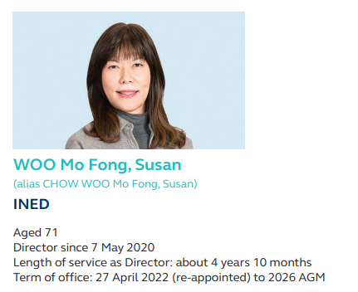

**Education Background**

* **Bachelor of Science**: Business Administration, The University of Bath, UK
* **Professional Qualification**: Solicitor (Hong Kong)

**Previous and Current Positions**

* **Current Position**:
  + **Title**: Independent Non-Executive Director
  + **Joined**: 7 May 2020
  + **Term of Office**: 27 April 2022 to 2026 AGM
* **Other Positions Held with the HKEX Group**:
  + Chairman of Listing Operation Governance Committee and Risk Committee
  + Member of Corporate Responsibility Committee, Remuneration Committee, and Risk Management Committee (statutory)
  + Member of Listing Nominating Committee, The Stock Exchange of Hong Kong Limited
  + Director, HKEX Foundation Limited
* **Other Major Offices**:
  + **Non-Executive Director**: Hutchison Telecommunications (Australia) Limited (2019~)
  + **Non-Executive Director**: CK Hutchison Holdings Limited (2017~)
* **Past Offices**:
  + **Alternate Director**: HK Electric Investments Manager Limited and HK Electric Investments Limited (2014-2023)
  + **Alternate Director**: CK Infrastructure Holdings Limited (2006-2023)
  + **Senior Advisor**: CK Hutchison Holdings Limited (2016)
  + **Executive Director and Group Deputy Managing Director**: CK Hutchison Holdings Limited (2015-2016)
  + **Director**: Hutchison Whampoa Limited (2015-2016)
  + **Deputy Group Managing Director**: Hutchison Whampoa Limited (1998-2015)
  + **Executive Director**: Hutchison Whampoa Limited (1993-2015)
  + **Partner**: Woo Kwan Lee & Lo (1985-1993)

**LinkedIn profile:** N/A

**LEUNG Pak Hon, Hugo**

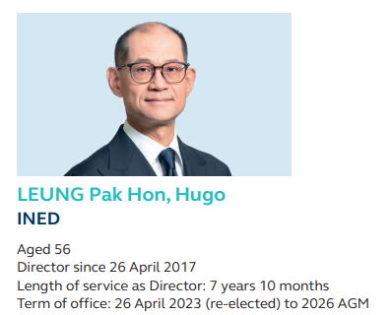

**Education Background**

* **Bachelor of Arts**: Economics, Simon Fraser University, Canada

**Previous and Current Positions**

* **Current Position**:
  + **Title**: Independent Non-Executive Director
  + **Joined**: 26 April 2017
  + **Term of Office**: 26 April 2023 to 2026 AGM
* **Other Positions Held with the HKEX Group**:
  + Member of Audit Committee, Board Executive Committee, Investment Committee, Risk Committee, and Risk Management Committee (statutory)
  + Director, HKEX Global Commodities Limited
  + Chairman and Independent Non-Executive Director, OTC Clearing Hong Kong Limited
* **Other Major Offices**:
  + **Chief Executive Officer**: BNP Paribas, Hong Kong (2019~)
  + **Chief Executive Officer**: BNP Paribas Securities (Asia) Limited (2015~)
* **Past Offices**:
  + **Head of Global Markets**: BNP Paribas, Hong Kong (2015-2019)
  + **Head of Global Equities and Commodity Derivatives**: BNP Paribas, Greater China (2013-2015)
  + **Deputy Chief Executive Officer**: BNP Paribas Securities (Asia) Limited (2012-2015)
  + **Head of Equity Syndicate and Corporate Equity**: BNP Paribas Securities (Asia) Limited (2010-2012)
  + **Head of Equity Brokerage**: BNP Paribas Securities (Asia) Limited (2007-2010)
  + **Head of Asia (ex-Greater China) Product**: BNP Paribas Securities (Asia) Limited (2004-2007)
  + **Product Sales Head for Taiwan**: BNP Paribas Securities (Asia) Limited (2003-2004)
  + **Deputy Managing Director**: BNP Paribas Securities (Asia) Limited (2000-2003)

**LinkedIn profile:** <https://hk.linkedin.com/in/hugo-leung-311057164?original_referer=https%3A%2F%2Fwww.google.com%2F>

**YAM Chi Kwong, Joseph**

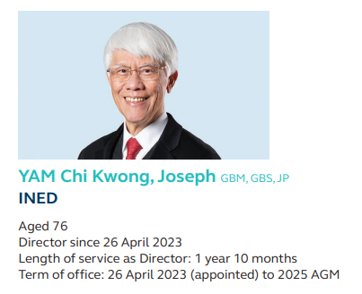

**Education Background**

* **Bachelor of Social Sciences**: The University of Hong Kong
* **Professional Qualifications**:
  + Fellow, Chartered Institute of Bankers
  + Honorary Advisory President, The Hong Kong Institute of Bankers
  + Fellow, Hong Kong Academy of Finance

**Previous and Current Positions**

* **Current Position**:
  + **Title**: Independent Non-Executive Director
  + **Joined**: 26 April 2023
  + **Term of Office**: 30 April 2025 to 2027 AGM
* **Other Positions Held with the HKEX Group**:
  + Member of Investment Committee, Remuneration Committee, and Risk Committee
* **Other Major Offices**:
  + **Global Advisor**: Sumitomo Mitsui Banking Corporation (2018~)
  + **Member of Management Committee**: Lau Chor Tak Institute of Global Economics and Finance, The Chinese University of Hong Kong (2018~)
  + **Distinguished Research Fellow**: Lau Chor Tak Institute of Global Economics and Finance (2010~)
* **Past Offices**:
  + **Independent Non-Executive Director**: Johnson Electric Holdings Limited (2010-2024)
  + **Independent Non-Executive Director**: UnionPay International Co Ltd (2012-2024)
  + **Director**: UBS AG (2011-2017)
  + **Independent Non-Executive Director**: China Construction Bank Corporation (2010-2013)
  + **Chief Executive**: Hong Kong Monetary Authority (1993-2009)
  + **Director of the Office**: The Exchange Fund of Hong Kong (1991-1993)
  + **Various Positions**: Hong Kong Government (1971-1991), including Deputy Secretary for Monetary Affairs (1985-1991)
* **Public Service**:
  + **Member**: Supervisory Managing Organisation of The Nina and Teddy Wang Charitable Trust (2025~)
  + **Non-Official Member**: Executive Council of the Hong Kong Special Administrative Region (2017~)

**LinkedIn profile:** N/A

**ZHANG Yichen**

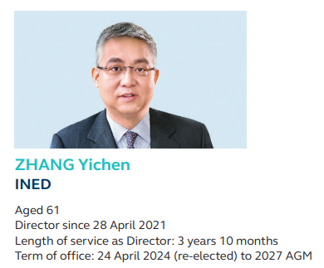

**Education Background**

* **Bachelor of Science**: Computer Science, The Massachusetts Institute of Technology (MIT), US

**Previous and Current Positions**

* **Current Position**:
  + **Title**: Independent Non-Executive Director
  + **Joined**: 28 April 2021
  + **Term of Office**: 24 April 2024 to 2027 AGM
* **Other Positions Held with the HKEX Group**:
  + Chairman of Mainland China Advisory Group
  + Member of Corporate Responsibility Committee, Investment Committee, and Nomination and Governance Committee
  + Director, HKEX Foundation Limited
* **Other Major Offices**:
  + **Chairman and Chief Executive Officer**: CITIC Capital Holdings Limited (2003~)
  + **Independent Non-Executive Director**: China Vanke Co Ltd (2020~)
* **Past Offices**:
  + **Non-Executive Director**: AsiaInfo Technologies Limited (2018-2024)
  + **Chairman and Director**: Harbin Pharmaceutical Group Co Ltd (2021-2023)
  + **Director**: S F Holding Co Ltd (2016-2022)
  + **Chairman and Non-Executive Director**: Genertec Universal Medical Group Company Limited (2012-2021)
  + **Independent Director**: SINA Corporation (2002-2021)
  + **Non-Executive Director**: Frontier Services Group Limited (2020-2021)
  + **Deputy Chief Executive Officer**: CITIC Capital Holdings Limited (2002-2003)
  + **President**: CITIC Pacific Communications Limited (2000-2002)
  + **Executive Director**: CITIC Limited (2000-2002)
  + **Managing Director**: Merrill Lynch Asia Pacific (1996-2000)
* **Public Service**:
  + **Member**: The National Committee of the Chinese People’s Political Consultative Conference (2008~)

**LinkedIn profile:** <https://hk.linkedin.com/in/yichen-zhang-92a7a312>

**Peter Wilhelm Hubert BRIEN (since 30 April 2025)**

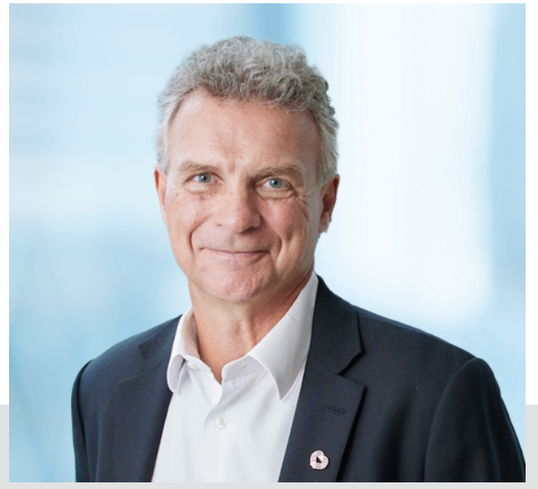

**Education Background**

* **Bachelor of Laws**: University of Birmingham, UK
* **Professional Qualifications**: Solicitor (Hong Kong and England & Wales)

**Previous and Current Positions**

* **Current Position**:
  + **Title**: Independent Non-Executive Director
  + **Joined**: 30 April 2025
  + **Term of Office**: 30 April 2025 to 2028 AGM
* **Other Positions Held with the HKEX Group**:
  + Member of Audit Committee, Board Executive Committee, Listing Operation Governance Committee, and Risk Committee
* **Other Major Offices**:
  + **Chairman and Independent Non-Executive Director**: Chinachem Group Holdings Limited (2024~)
  + **Non-Executive Director**: The Hong Kong Philharmonic Orchestra (2022~)
  + **Member of General Committee**: Hong Kong Club (2022~)
* **Past Offices**:
  + **Member of the Chairmen Pool**: Listing Review Committee, The Stock Exchange of Hong Kong Limited (2024-2025)
  + **Chairman**: Listing Committee of the Main Board and GEM, The Stock Exchange of Hong Kong Limited (2020-2022)
  + **Deputy Chairman**: Listing Committee of the Main Board and GEM (2017-2020)
  + **Member**: Listing Committee of the Main Board and GEM (2015-2017)
  + **Senior Consultant**: Slaughter and May, Hong Kong (2022-2024)
  + **Senior Partner**: Slaughter and May, Hong Kong (2013-2022)
  + **Partner**: Slaughter and May (1995-2013)

**LinkedIn profile:** N/A

**DING Chen**

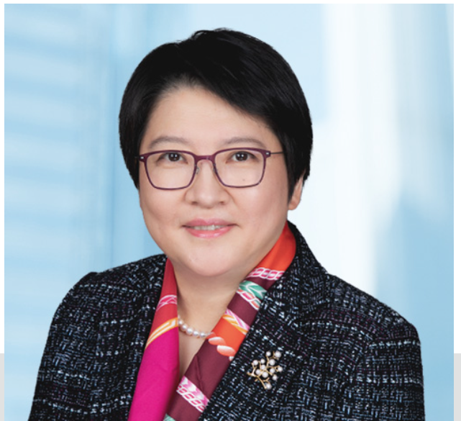

**Education Background**

* **Master of Business Administration**: San Francisco State University, US
* **Bachelor of Electrical Engineering**: Sichuan University, PRC

**Previous and Current Positions**

* **Current Position**:
  + **Title**: Independent Non-Executive Director
  + **Joined**: 30 April 2025
  + **Term of Office**: 30 April 2025 to 2027 AGM
* **Other Positions Held with the HKEX Group**:
  + Member of Corporate Responsibility Committee, Investment Committee, and Risk Committee
  + Director, HKEX Foundation Limited
* **Other Major Offices**:
  + **Chief Executive Officer and Director**: CSOP Asset Management Limited (2008~)
* **Past Offices**:
  + **Member**: Listing Review Committee of the Main Board and GEM, The Stock Exchange of Hong Kong Limited (2019-2020)
  + **Assistant Chief Executive Officer, Managing Director**: China Southern Asset Management Co Ltd (2003-2013)
  + **Associate General Manager**: China Merchants Securities Co Ltd (2001-2003)
  + **Investment Manager**: M L Stern & Co LLC (2000-2001)
* **Public Service**:
  + **Non-Official Member**: Task Force on Enhancing Stock Market Liquidity (2023~)
  + **Vice-Chairman**: Financial Services Development Council (2023~)
  + **Director**: Financial Services Development Council (2019~)
  + **Convenor**: Mainland Opportunities Committee, Financial Services Development Council (2019~)
  + **Member**: Mandatory Provident Fund Schemes Appeal Board (2019~)

**LinkedIn profile**: <https://hk.linkedin.com/in/chen-ding-csop?trk=public_post_feed-actor-name>